*Heat Check*:

A Case Study of Infamous Streaky Shooting

Fisayo Omilana

June 8, 2018

*Introduction*

The 2018 NBA Finals feature two of the NBA’s most notorious streaky shooters. One might guess this pair to be some combination of the lethal three-headed dragon of Stephen Curry, Klay Thompson, or Kevin Durant. All three of the latter mentioned players are superstar sharpshooters but are not the streaky shooters of interest. Very few players have essentially been able to make full-blown professional careers and craft fan-favorite personas based solely on their ability to get hot like Nick Young and J.R. Smith. Both have reputations for taking ill-advised and/or contested shots, seemingly living their lives by the mantra, “shooters shoot.” Furthermore, both have reputations of actually making those shots to the often-pleasant surprise of teammates, coaches, and raving fans alike. The similarities don’t stop there though.

For example, both have outrageous but fitting self-proclaimed nicknames: J.R. Swish and Swaggy P. They are the same age: 32 (as of June 2018). Both started of their careers on low profile teams: Smith on the Nuggets, and Young on the 76ers. Both made names for themselves on these teams as regular off-the-bench energizers. After that, their careers only followed even more similar paths with both of them having stints with historic franchises in the USA’s biggest cities and posting career high point-per-game averages: Young averaging 17.9 PPG on the Los Angeles Lakers, and Smith averaging 18.1 PPG on the New York Knicks. Finally, as previously mentioned, both are currently on championship contending teams: Smith on the Cleveland Cavaliers, and Young on the Golden State Warriors. Neither of them are recognized as complete basketball players but both have been able to thrive in this league with their knack to score in handfuls. A comparison of their career statistics is even more revealing of their likeness:

|  |  |  |
| --- | --- | --- |
|  | J.R. Smith[1] | Nick Young[2] |
| PPG | 12.6 | 11.4 |
| AST | 2.1 | 1.0 |
| REB | 3.2 | 2.0 |
| FG% | 41.9 | 41.8 |
| 3PT% | 37.4 | 37.6 |
| PER  (Player Efficiency Rating) | 14.0 | 12.9 |

Comparing J.R. Smith and Nick Young certainly passes the eye test of the average NBA fan, and these numbers only further validate this reasonable hunch. One might even say that they are the same player. So, all these similarities piqued my curiosity and led me to question: Who is the streakier shooter?

*Methods*

To properly assess this question, I wanted to specifically pay attention to each player’s streakiness and nothing else. Borrowing a similar methodology from a journal by Shun-Chuan Chang[3], I decided to approach the problem by comparing the conditional probabilities of J.R. Smith and Nick Young making or missing their next shot based on a prior outcome. The priors of these conditional probabilities would be based on the current run. For the purpose of this study, I defined a “run” as one or more consecutive made or missed shots. One or more previously missed shots is represented by a negative number and missing the next shot is classified as the shooter being cold. Conversely, one or more previously made shots is represented by a positive number and is making the next shot is classified as the shooter being hot. For clarity’s sake, here are several examples of this:

*P(hot|2) = field goal percentage for making the next shot after making the last two shots*

*P(hot|-2) = field goal percentage for making the next shot after missing the last two shots*

*P(cold|2) = field goal percentage for missing the next shot after making the last two shots*

*P(cold|-2) = field goal percentage for missing the next shot after missing the last two shots*

In this format, I planned to compare and contrast Smith and Young’s conditional field goal percentages and various features associated with each unique streak.

*Data*

I used two regular season data sets from BigDataBall.com. I chose the 2012-13 and 2013-14 regular seasons because these were the years when J.R. Smith and Nick Young were in their prime (age 27 and 28, respectively). They both set career-high scoring averages in each year. These were also the least disparate seasons between Smith’s and Young’s number of games played and minutes. Ideally, I would have used their whole careers but since I had to pay for this data, I sampled with what I could afford.

My data contained play-by-play information for every game occurring during each season. So, using R, I processed the data to only analyze the games where J.R. Smith and Nick Young played by filtering with respect to their team’s abbreviations. Coding the correct functions to properly calculate the conditional probabilities for each game and adding it to a cumulative data structure was, by far, the hardest part of this project. Many edge cases needed to be handled plus the run time had to be seriously optimized for efficiency. I did not incorporate continuous game-to-game streaks. So, once a game ended, I defined that streak as ending too.

*Results*

Overall, I did not find any convincing trend that J.R. Smith nor Nick Young’s field goal percentage increased as they continued to make more and more shots. This was not concerning because it was consistent with other investigations about the hot hand fallacy. Most researchers concur that prior success can possibly change the psychological behavior of a shooter, but there is no *significant evidence* to prove a *definitive* increase in shot making probability regardless of the shooter’s prior outcomes. Although the hot hand makes intuitive sense, it simply doesn’t exist. It is a result of the human brain’s natural tendency to try and perceive patterns in randomness. Cold streaks and hot streaks are a normal yet alluring side-effect of chance. Defining the shot outcome as a random variable, these cold streaks and hot streaks reach an equilibrium over time, according to the Law of Large Numbers. Such an all-encompassing shot distribution should be reflective of a player’s general field goal percentage.

Nevertheless, I only sought to compare the two players’ streakiness regardless of legitimacy. Over the two seasons, I came to the conclusion that J.R. Smith was streakier than Nick Young. Smith’s longest hot streak (11 makes in a row) was more than Young’s longest hot streak (8 makes in a row). Smith also had the longest cold streak (10 misses in a row) compared to Young’s longest cold streak (8 misses in a row). In addition, for the streaks with adequate sample sizes (1 - 4 made or missed consecutive shots), Smith was a net 12.4% more likely than Young to make his next shot based on prior made shot(s), and a net 13.6% more likely than Young to miss his next shot based on prior missed shot(s).

After all the desired information was properly organized in my data structure, I plotted graphs of the conditional shooting percentages. Like Figures 1A and 1B exhibit, there is a general decline in shooting percentage for both players while on hot streaks. Also, both graphs had a decreasing probability of staying cold until the third consecutive miss. At that point, the missed shot probability went back up. These results prompted me to think about why the graphs looked this way. Stepping back from the numbers to a purely basketball standpoint, I thought about what might explain these trends. Using a website called 3ball.io, I watched film of J.R. Smith and Nick Young to gain a better idea of how the data translates to their on-court play.

The trend in shooting percentages while cold can be explained by an example series of plays against the Boston Celtics after Nick Young misses a dunk[4]. Like one might assume, that can be an embarrassing moment. Following that botched slam, Nick Young also air-balls a wide open three. On his next shot attempt, Nick Young air-balls another pull-up midrange jumper, where he is seen shaking his head afterwards. He was subsequently taken out of the game. It makes sense to conclude that after a missed dunk and two air-balls, Nick Young’s confidence was waning that game and his percentage likewise suffered. This is representative of the negative psychological effect of missing multiple shots and is also reflective of my result in Figures 1A and 1B when miss percentage increases after 3 consecutive missed shots.

For the hot hand plot, I hypothesized that shot selection was a big reason for this general decline. This was where I found the most interesting insight, in my opinion. Along with conditional shooting percentages, I decided to add to my cumulative data structure by calculating the average points and average shot distance at each streak length. After plotting these averages, I felt my hypothesis was visibly proved to be correct. As seen in Figures 3A and 3B, J.R. Smith and Nick Young shot selection stays relatively consistent when they were on a cold streak. However, when on a hot streak, both players’ shot distance steadily increases and takes a big jump further back after the third made shot. I identified the outlier distance on their fourth shot to be reflective of their classic heat check[5]. Furthermore, as depicted by Figures 2A and 2B, with an escalating shot distance as a hot streak continues, the expected points scored decreases as a response.

*Conclusion*

Along with their polarizing personas and hilarious on-court celebrations, J.R. Smith and Nick Young are most infamous for making a couple shots and then wildly attempting a “heat check.” These shots are a result of poor shot selection usually characterized as off-balanced fadeaway jump shots, highly contested step-back threes, and/or being after a series of flashy dribble moves.

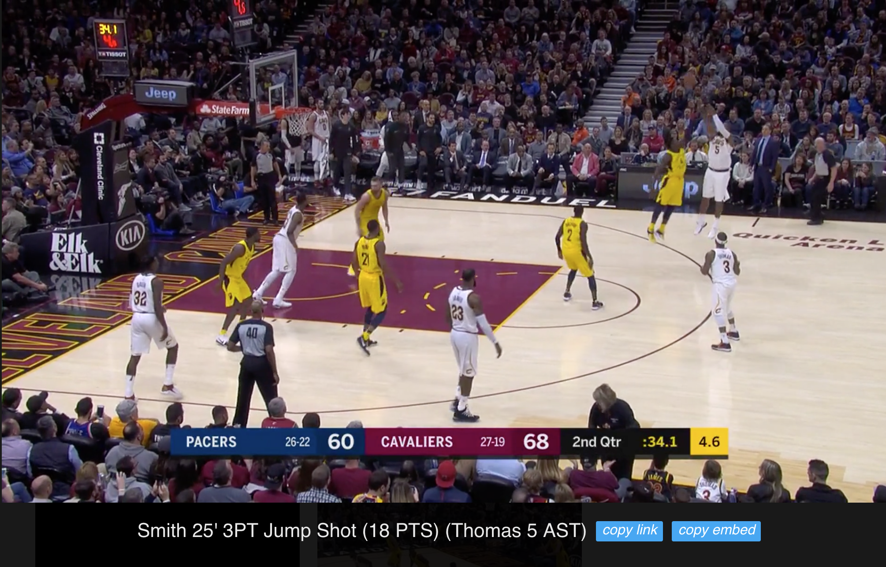

<http://www.3ball.io/plays?evtt=1&p1id=2747&playId=0021700715_297>

The made shot depicted above is a combination of all three characteristics. Feeling hot, later in this same game, J.R. Smith took another ill-advised heat check: a pull-up transition three pointer while on a fast break with LeBron James and two retreating defenders. He missed and there was obviously a better decision to be made with the best player in the world running towards the lane. Naturally, these types of shots don’t have the best chance of going in the hoop. But players like J.R. Smith and Nick Young seemingly can’t resist taking this heat check, and thus are the very few who make them. When they make these shots, one can’t help but cheer and laugh at how typical it is. In the long-run, the numbers reveal this inefficiency… but Swaggy P and J.R. Swish could care less about efficiency and that’s why fans, including myself, love watching them play.

APPENDIX

**

**FIGURE 1A**

**

**FIGURE 1B**

**

**FIGURE 2A**

**

**FIGURE 2B**

**

**FIGURE 3B**

**FIGURE 3A**

**

1. “J.R. Smith Stats.” *Basketball-Reference.com*, https://www.basketball-reference.com/players/s/smithjr01.html.
2. “Nick Young Stats.” *Basketball-Reference.com*, www.basketball-reference.com/players/y/youngni01.html.
3. Article Source: [*Capability and opportunity in hot shooting performance: Evidence from top-scoring NBA leaders*](http://journals.plos.org/plosone/article?id=10.1371/journal.pone.0179154)Chang SC (2018) Capability and opportunity in hot shooting performance: Evidence from top-scoring NBA leaders. PLOS ONE 13(2): e0179154. <https://doi.org/10.1371/journal.pone.0179154>
4. <http://www.3ball.io/plays?p1id=201156&evtt=1%2C2&playId=0021700728_124>
5. <https://www.google.com/search?ei=J0dIW7_3DJeQjgSMu6iYBg&q=heat+check&oq=heat+check&gs_l=psy-ab.3..35i39k1j0i227i67k1j0i20i263k1j0l3j0i227i67k1j0l3.1418.2738.0.2969.3.2.1.0.0.0.311.596.2-1j1.2.0..3..0...1.1.64.psy-ab..0.3.597....0.slHYqREekOM>